📄 Test Case: TC49_LodgetheOutwardBill
❌ FAILED:
[2026-02-20 15:15:16] ? Error: G69 - The bill is already lodged.
[2026-02-20 15:15:16] ? Assertion Failure: Test failed: G69 - The bill is already lodged.
↳ Reason: ❌ ❌ Assertion Failure: Test failed: G69 - The bill is already lodged.

📸 Screenshot:
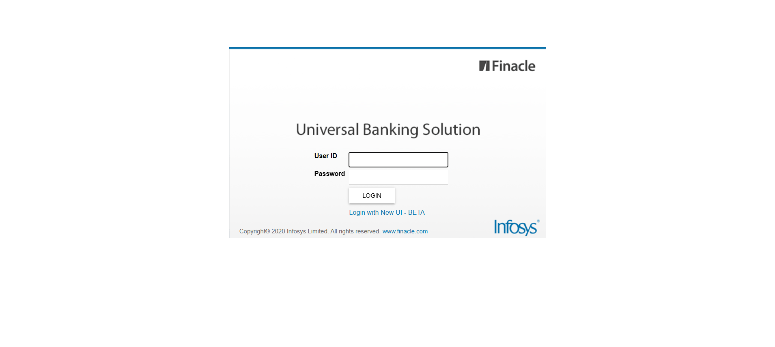
============================================================
📊 Suite Summary: Test
===============================================
Test
Total tests run: 1, Passes: 0, Failures: 1, Skips: 0
===============================================
⏱️ Total Duration: 00 min 43 sec

